2014 UK Event pros and cons auction reserve price.pdf

_______________________________________________________________________________________
Department of Energy and Climate Change, January 2014. GB: EU ETS Structural Reform Stakeholder Event.

Synthesis :
This report does not represent government policy but the result of collegial discussion and exploration of possible option for reform of the EU ETS. Advantages/Disadvantages of each of triggers discussed by about thirty people from different horizons (public/private sector – industry/finance/organization) are described for the four identified triggers to achieve objectives(providing a more stable low carbon investment signal, increasing resilience and predictability of response to external shocks, and addressing the surplus) :
- Surplus maximum and minimum threshold
- Surplus maximum threshold and price ceiling or maximum price rise
- Price ceiling and price floor
- Deviation of economic indicators from expected level (e.g. GDP or production)
All these schemes are developed in favour of an adjustment of the EU ETS cap to align it with EU emissions reductions targets for 2030 and 2050 and cancellation of an ambitious volume of allowances to reduce the existing surplus and help restore the balance between supply and demand

Arguments for and against a minimum carbon price
FOR | AGAINST
“Most economically efficient option” compare to others proposals in the paper (p6) | “Politically undo-able (similar to TAX) / Difficulty of negotiating” (p6)
“Greater certainty for investment decisions, and over government revenues, akin to a carbon tax ” (p6) | “Furthest away from market-based system, particularly if collar too narrow” (p6)
“Provide stable signal for investment and cover risk premiums ” (p6) | “Loses short term benefit to industry of low prices” (p6)
“Remove extreme downside price risk If prices much different than expected when level of ambition agreed politically” (p6) | “Lack of impact if set too high or low.” (p6)
“Price certainty of some kind would at least get investment in low carbon industry going” (p6) | “Need to set band wide enough (price ceiling and price floor). In case of narrow price corridor, use a carbon tax” (p13)

YES Shell David Hone.docx

_______________________________________________________________________________________
Hone D., (Climate Change Advisor for Shell) 7th June 2012. GB: A new market mechanism from the UNFCCC.

Arguments for and against a minimum carbon price
FOR | AGAINST
“A floor price, even if not pitched particularly high, shifts the carbon pricing risk on a project at least to some extent” (p1) | “In a permit system it is the number of permits: the price of the permits shows how expensive or cheap it is to meet the target” (p1)
“Hybrid instruments offer the potential for providing greater certainty regarding prices and investment signals, while maintaining the advantages of a trading scheme” (p2) | “It is too late to do this for Phase III of the EU ETS (2013-2020)” (p2)
“A price floor gives greater certainty about the minimum return to their investments” (p2) | “Loses short term benefit to industry of low prices” (p6)
“An advantage of having a reserve price is that independent of its function as a price floor, it is an auction design feature that can protect sellers and in some cases buyers from unexpected outcomes in the auction” (p2)
“remove large perceived downside risks, support low-carbon investment decisions, and reduce the cost of capital, which could result in substantial economic savings” (p3)
“can reduce excessive price volatility, improves predictability of returns and increases expected returns for low-emissions investments” (p3)

YES Mistra INdigo 1484439_price-floor-eu-ets.pdf

_______________________________________________________________________________________
Burtraw D., Löfgren A., Zetterberg L., December 2013. US/SE: A Price Floor Solution to the Allowance Surplus in the EU ETS, Mistra Indigo (Instrument Design for Global Climate Mitigation)

Arguments for and against a minimum carbon price
FOR | AGAINST
“Price floor approach could reinforce the market-based philosophy and investment climate of the ETS.” (p1) | “an instrument that has historically faced political opposition,” (p2)
“It is widely viewed as a successful design feature that has stabilized prices and enhanced environmental outcomes” (p4) | “the commission states that an explicit carbon price objective would alter the nature of the EU ETS being a quantity-based market instrument” (p2)
“Prevents a collapse of the trading market as a result of serendipitous changes in the power system outside the market.” (p4) | “price floor has been mischaracterized as a tax, an instrument associated with political difficulties historically” (p5)
“price floor is not a tax” (p5)
“Some portion of the market including industry may receive allowances for free. The value of that allocation is reinforced by the price floor in the auction.” (p5)
“a price floor independently or in combination with a price cap significantly improves welfare and the performance of a trading program” (p6)
“low allowance price should trigger the desire to purchase greater emissions reductions” (p6)
“If implemented in phase 4 of the EU ETS, starting in 2020, a price floor would be likely to influence the minimum price for the later years of phase 3 because of the opportunity for banking” (p6)

Van der Werf_Presentation.pdf

_______________________________________________________________________________________
Van Der Werf E., Vollebergh H., Brink, C.L., December 2013. NL: Cost-effectiveness of EU ETS reform options, Wageningen University

Synthesis:
This document sums up works done by social sciences department of Wageningen University (NL) on economic based forecasts on several correlated parameters (effective C02 price / EUA price / ETS GHG emissions) according to different systems of regulation:
1. Tighter cap (linear reduction factor; 2.6 billion EUAs)
2. Permanent set aside (900 mln EUAs)
3. Auction reserve price €20 – unsold EUAs into reserve
4. Variable CO2 tax fossil fuels on top of EUA price; sum equal to €20 for power sector only (UK)
5. Variable CO2 tax fossil fuels on top of EUA price; sum equal to €20 for all ETS sectors
6. Fixed €20 CO2 tax fossil fuels for all ETS sectors
Modeling hypothesis and global methodology are consistent with equivalent papers found in literature, and results are described in following graphs:
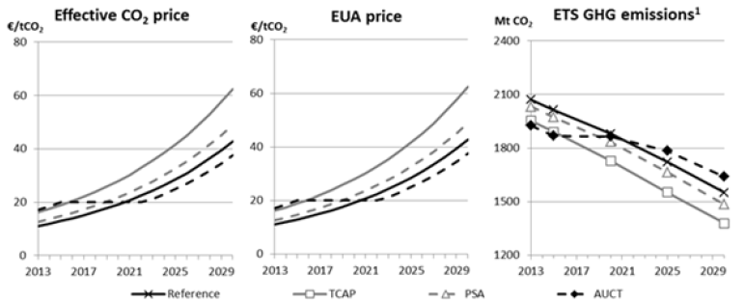
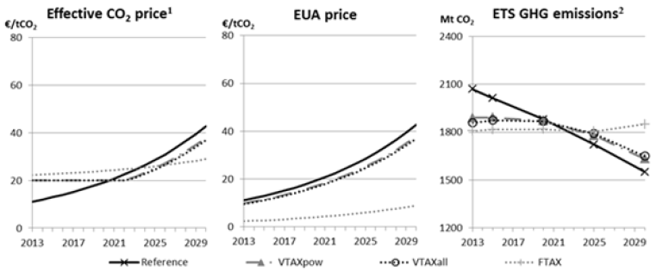

Arguments for and against a minimum carbon price
FOR | AGAINST
“Auction reserve price and fixed or variable CO2 tax introduce effective price floor.” (p10) | “Variable tax in different sectors is inefficient.” (p10)
“Fixed tax comparable to variable tax” (p10) | “Auction reserve price induces dispersed compliance costs” (p10)

Telecharger-le-resume-du-rapport.pdf

_______________________________________________________________________________________
Canfin P., Grandjean A., Juin 2015. Mobiliser les financements pour le climat : une feuille de route pour financer l’économie décarbonée. Rapport de la Commission Pascal Canfin – Alain Grandjean

Synthesis:
The report summarizes conclusions of global works achieved on different ways to move towards a low-carbon financial roadmap. Carbon Price Floor/Ceiling is one of the proposed systems to make efficient the transition to low-carbon economy.

Arguments for and against a minimum carbon price
FOR | AGAINST
“implement corridor carbon price with price floor around 15/20$/tCO2 in 2020 and price ceiling around 60/80$/tCO2 in 2030/2035” (p12) | “the introduction of sectoral and geographical flexibility is required to improve the political economy of such a reform” (p13)
“combines the strength of a common political message and the necessary flexibility to differentiate between countries and geographical zones, both in terms of price level and time horizon” (p12) | Committing to a minimum carbon price would ensure the improved efficiency of the scheme; a maximum carbon price provides important information to economic actors
“Committing to a minimum carbon price would ensure the improved efficiency of the scheme; a maximum carbon price provides important information to economic actors” (p12)
“The target price aimed for here is an ‘explicit’ price signal” (p13)

